Name : S.Pon Gayathri
Date : September 2026

Analysis of Freshers Hiring - India

Project objective
The objective of this project is to analyze the hiring of freshers based on their educational qualifications, skills and factors considered by companies during the hiring process. The project also aims to analyze the companies that hire the candidates as well as the job sectors and roles the candidates prefer to work in.

Dataset Information
Dataset Name : Freshers Hiring India Dataset
Source : Kaggle
Number of rows : 5000
Rows after cleaning : 2907
Number of columns : 30

Columns Explanation
- Candidate_ID
- Full Name
- Gender
- Age
These columns list the demographics of the candidates.
- College
- Branch
- Degree
- Graduation_year
- CGPA
- Backlogs
These columns tell about the educational qualification and the year the candidates graduated.
- Prior Internship – Indicates whether the candidates have completed internship or not.
- Projects _count – Number of projects done by the candidates
- Certifications_count – Number of certificates obtained by the candidates
- Top_skills - Technical skills acquired by candidates
- Job_platform - The job application platform through which the candidates applied for the job
- Company_applied – The companies to which the candidates applied for job
- Sector – The job sector in which the candidates prefer to work
- Job_role – The job role the candidates prefer to work.
- Work_type – The type of work the candidates prefer/applied for such as internship, full time or contract based job.
- Job_location - The city in which the candidates prefer to work or applied for the job.
- Application_date - The date on which the candidates applied for job
- Hiring_stage – The different stages of hiring process such as applied, shortlisted, technical interview, HR interview, offer, rejected and withdrawn. It indicates the stage reached by the candidates in the hiring process.
- Interview_rounds – Number of rounds the candidates went through in an interview
- Response_time_days - The number of days the company takes to respond to the candidates regarding the hiring process, interview rounds, joining date etc..,
- Offered_Salary_inr - it tells about the salary offered to the hired candidates.
- LinkedIn_connections – The number of people the candidates are connected to on linkedIn
- Profile_completion_pct – The percentage of candidates’ profile that have been completed
- LinkedIn_Premium - Indicates whether the candidates have linkedin premium
- Referral_applied- Indicates whether the candidates applied with reference from the particular company.

Tools Used
- Python – Data cleaning and statistical analysis
- MySQL – Data Analysis
- PowerBI – Data Visualization

Data Cleaning
I performed data cleaning and statistical analysis using Python (Jupyter Notebook).
I imported libraries such as Pandas, Numpy, Stats and ttest_ind.
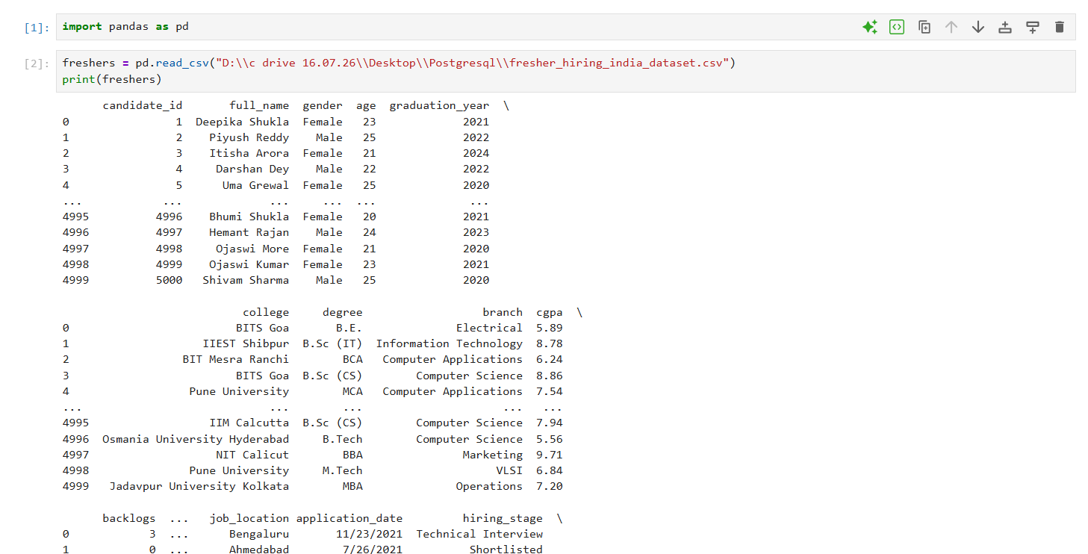

- I imported the fresher’s hiring India dataset to python (Jupyter Notebook) and saved it in a variable called “freshers”.
- I inspected the dataset using head(), tail(), describe(), info(), column, shape, index, iloc, len() to understand the data types, data structure, values, summary statistics.
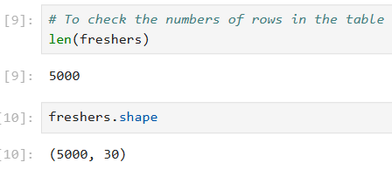
Checking for missing values
To check if there are any missing values, I used freshers.isnull().sum(). It adds all the null values in each columns.

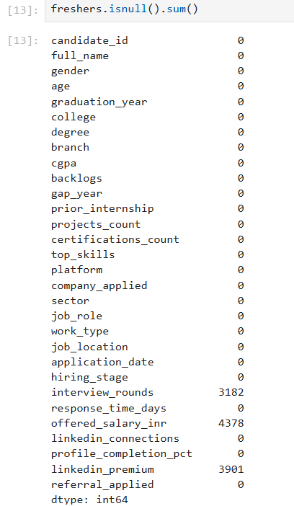
- It has missing values, so I filled the null values with “Not Available”, because the candidates who haven’t been hired by the company won’t be getting salary and the candidates who have been selected in each round in an interview wont be attending the next round.
- There are null values in the column LinkedIn premium column indicate that the information about the candidates having LinkedIn premium is not available, so I filled it with “Not Available”.
Checking for duplicates
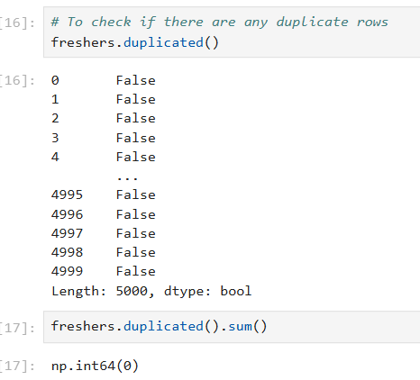
- I checked for duplicate rows to see if there are any candidates records that are repeated , it has no such rows.
Changing the data type
- Changed the datatype of the application_date, since it is in object type, I changed it into datetime type.
Removing illogical rows
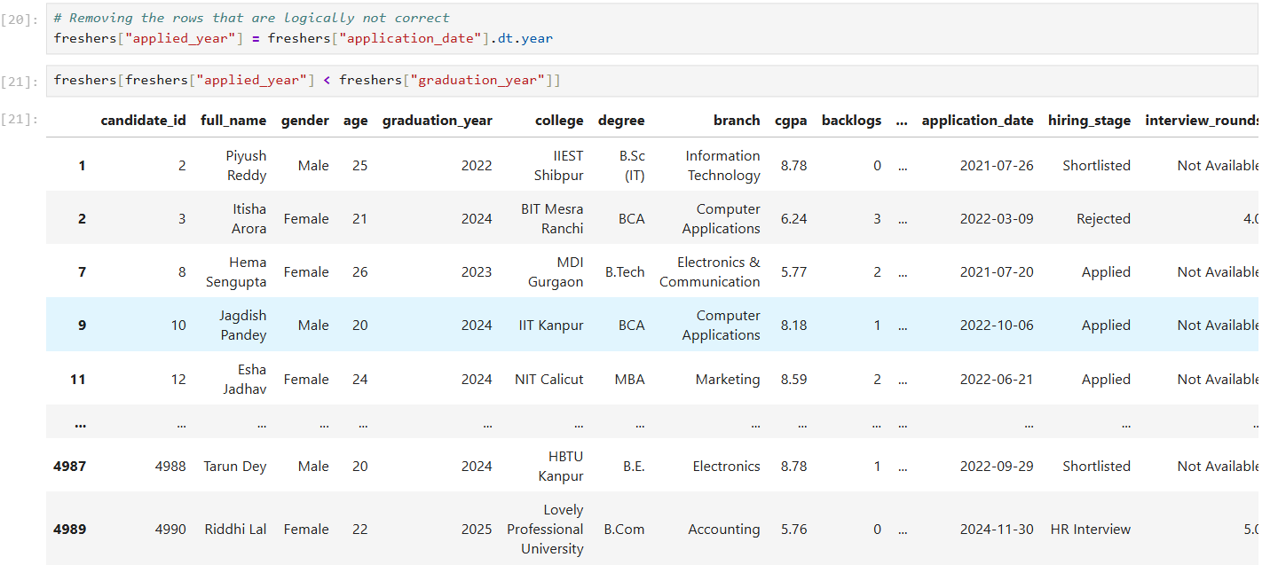
- There are rows where the applied year is earlier than graduated year. Only once we complete our graduation we could be able to apply for jobs, but there are records where the applied year is 2 or more years earlier than the graduated years, that is logically not possible.
- So, I created a new column named applied year and took only the year from the application_date column.
- There are 2093 rows where the applied year is less the graduated year, so I removed those rows and kept the rows that are only logically correct.
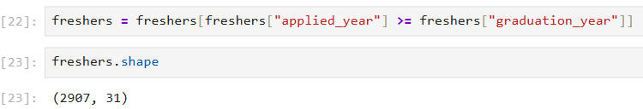
- After removing such rows now there are 2907 rows.
Adding new columns
- I added two new columns named skill_set_count and career gap.
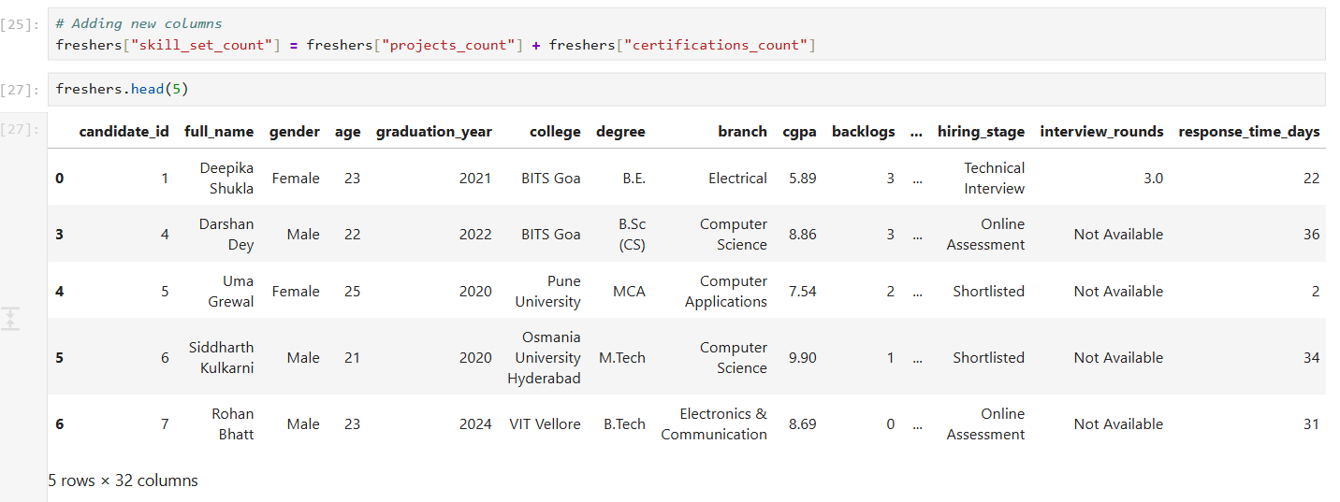
- To know how many projects and certificates they have in total, I added the projects_count column and certifications_count column and named it as skill_set_count.
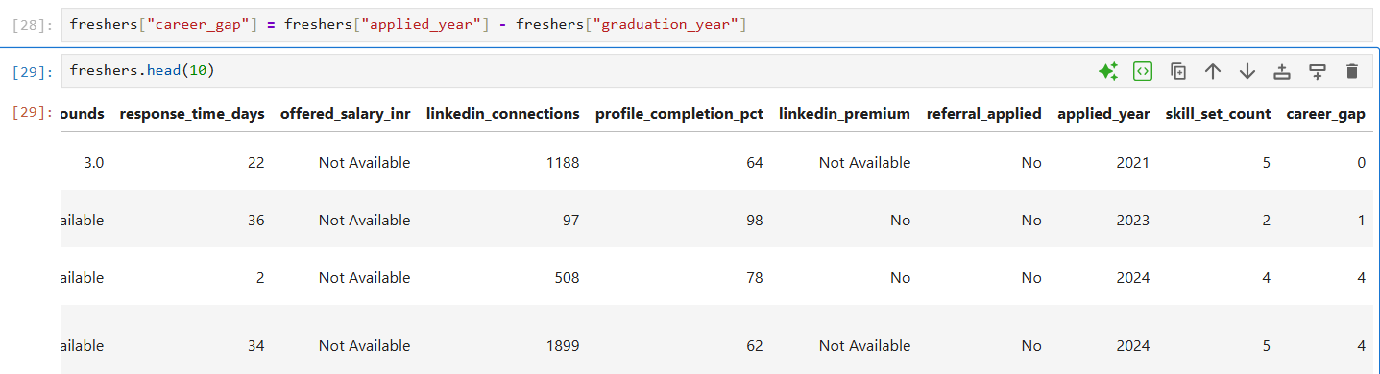
- To know if there is any gap between applied year and graduated year, I created a new column called career gap by subtracting those two columns.
Checking for Outliers
- To remove any inconsistent values or the values that are not logically correct in the age column, I used quartile method. For that I imported the library Numpy.
- I calculated the first quartile, Q1(25%), third quartile, Q3(75%) and Interquartile Range(IQR) to identify if there are any values outside the acceptable range.
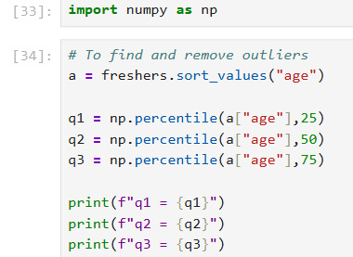
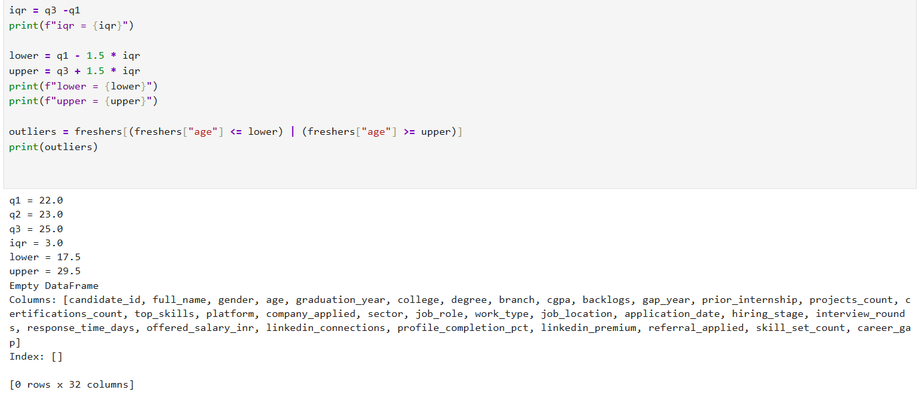
- There is no outliers in the age column.
Trimming Extra Spaces
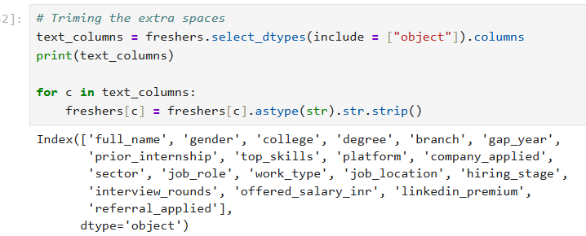
- I trimmed the extra spaces in the object types column. Numeric columns do not require this operation as they contain numerical values,
- When working with text data, there can be unwanted spaces at the beginning and end of text value
- Python treats them as different strings.These extra spaces can cause problems during data analysis, filtering, grouping, merging.
- The column headers are in lower case, I changed the first letter of each word to upper case using title().
Renaming the columns
- I renamed 2 columns, I converted all the letters of “Cgpa” into upper case , changing it to “CGPA”.
- There is a column named platform I changed it into Job_Application_Platform , since the values indicates the platform where the candidates apply for jobs.

Statistical Analysis
Two sample T-Test – Two Tailed
I wanted to check whether the candidates who are hired have higher project count, that is to check if there is any difference between that projects count of candidates who are hired and that of who are not hired.
- To check whether the candidates are hired based on higher number of projects..
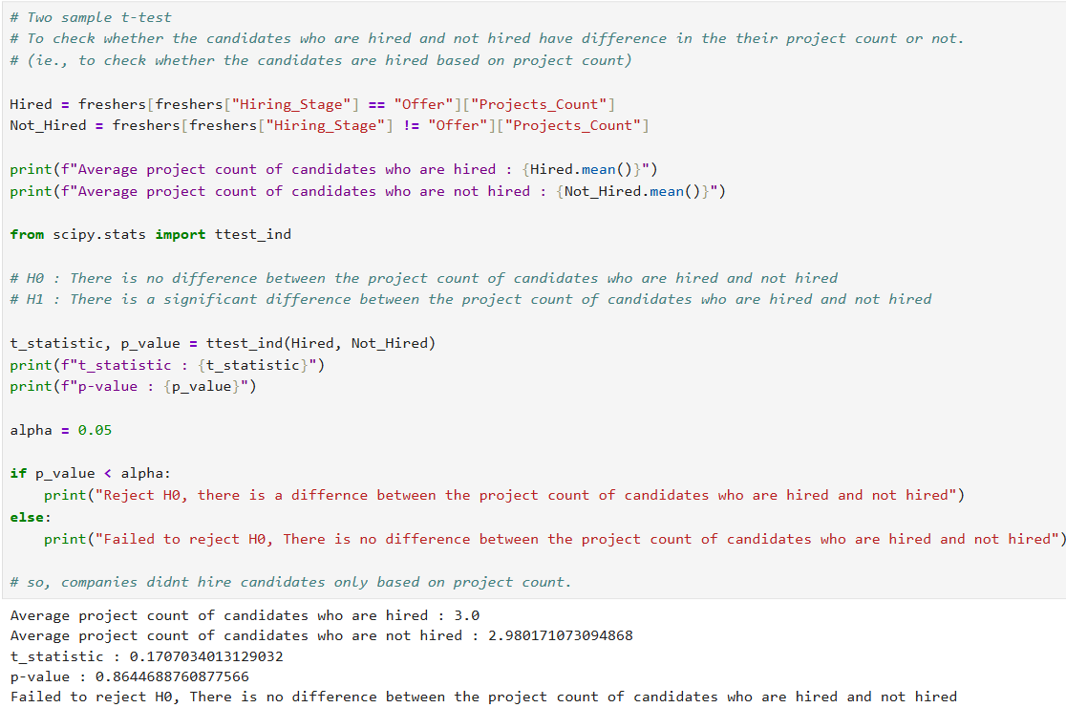
- We set the hypothesis, H0 which implies there is no difference between the average number of projects of the candidates who are hired and that of who are not hired
- H1 implies there is a difference between the average number of projects of the candidates who are hired and that of who are not hired.
- Since, we are going to compare two different groups, we use two- sample and we are going to compare the average so we use T-Test and we are going to check if the average project count of hired candidates is more or less than that of candidates who are not hired,it is 2-tailed, so we on the whole we use, Two sample T-Test 2-tailed.
After testing, we found that the candidates are not hired based projects count alone
- Here the t-statistic indicates the difference between the average number of projects of the candidates who are hired and that of candidates who are not hired.
- Alpha(significance level) is set upto 0.05(5%). If the p-value is less than 5%, the result is significant, meaning the difference is unlikely to have occurred by chance, if the p-value is greater than 5%, the difference is not real, it happened by chance.
- P-value indicates the chance that this difference happened by chance.
- Here the p-value says there is 86% chance that this difference(t- statistic=0.17) happened by luck which is more than Alpha(5%).
- So this difference is not real it happened by luck, so Accept H0, there is no difference between the average number of projects of the candidates who are hired and that of candidates who are not hired
Correlation
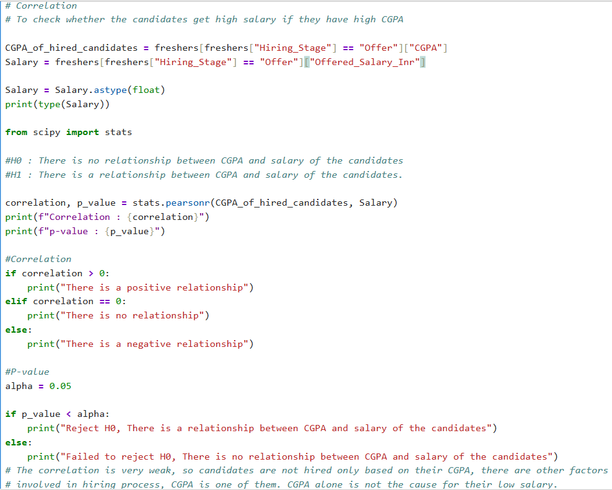
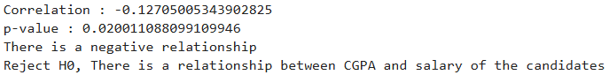
I checked if CGPA and salary are related that is the candidates who have high CGPA are getting high salary or not. So we use correlation.
Since the offered_salary_inr column is in text type I changed it as float type for this operation.
- I set the hypothesis, H0 – There is no relationship between CGPA and salary
H1- There is a relationship between CGPA and salary.
- Correlation ranges from -1 to 1, (-1to -0.9) represents there is a negative relationship that is candidates with low CGPA get high salary or vice versa. 0 represents there is no relationship and ( 0.9 to 1) represents there is strong relationship.
- Here the correlation value is -0.1 there is a negative relationship that is candidates with low CGPA gets high salary.
- P-value represents what is the chance that this relationship happened by luck. Here the p-value is 0.02 that is 2% that is there is 2% chance that this relationship happened by luck. It is less than 5% so it is acceptable.
- Reject H0, there is a relationship between CGPA and salary, but the relationship is very weak(-0.1 represents the relationship is very weak) that is low CGPA alone didn’t lead to high salary, there might be other reasons for this high salary, low CGPA is one of them.
Probability
To find the probability of choosing a candidate who has reference:
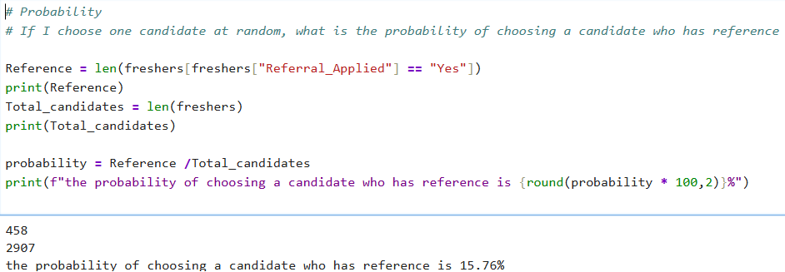
Descriptive Statistics
I performed mean(), median(), mode(), var(), std() in numerical columns.
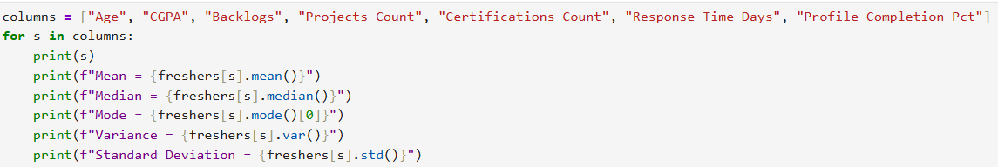

Data Analysis
Analyzed this dataset in MySQL.
1)Are candidates with backlogs hired the most?
Business question:
Show the companies where more candidates with arrears were hired than the candidates with no arrears and rank those companies.
SQL approach:
I compared the number of candidates with backlogs who were hired with number of candidates with no backlogs who were hired, I showed the companies which hired candidates with backlogs more than the candidates with no backlogs.
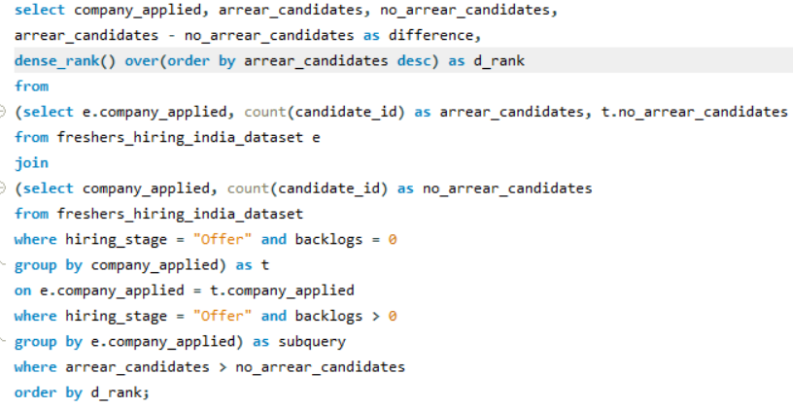
Result:
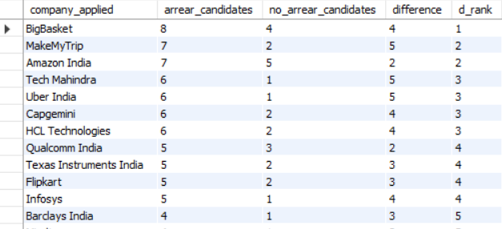
Business Insight:
More companies hired the candidates with backlogs. Bigbasket hired the most number of candidates with backlogs than other companies.
2)Do colleges with high CGPA as well as high backlogs exist?
Business question:
show the colleges with high average CGPA as well as high average backlogs .How many candidates are from those colleges?
SQL approach:
To find out if there are colleges with high CGPA as well as high backlogs, I calculated the average CGPA and average backlogs of each college. I ranked them separately based on average CGPA and average backlogs and identified the colleges that ranked in top 5 in both CGPA and backlogs. I also calculated the number of students studied in those colleges.
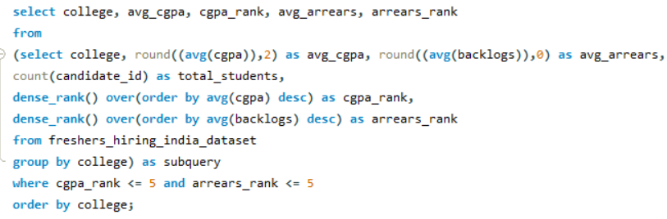
Result:
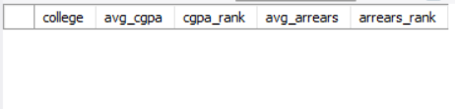
There are no colleges where they rank in top 5 in both CGPA and backlogs. There are no colleges with high CGPA as well as high backlogs.
3) Companies with high salary and quick response.
Business question:
Show the average number of days a company takes to respond and the average salary they offer. Show the companies which respond quickly and gives high salary.
SQL approach:
I calculated the average response time each company takes and the average salary each company offers. I ranked the average salary from highest to lowest and the average response time from lowest to highest and identified the companies which are ranked at top 5 in both average salary and average response time to show which companies are good at better salary and quick response.
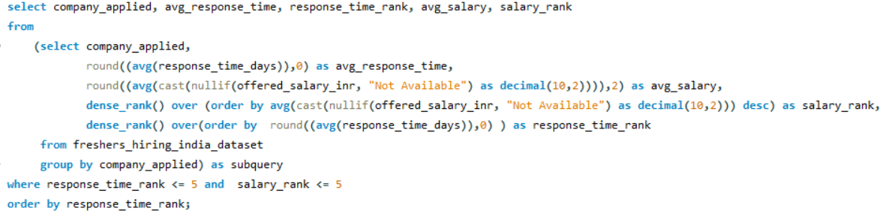
Result:
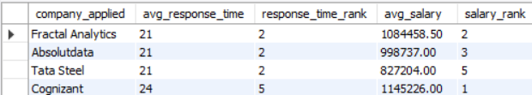
Business Insight:
These are the four companies which ranked at top 5 in both average response time and average salary. They provide better salary and respond quickly compared to others in the dataset.
4) Checking whether the students studied at IIT institutes receive higher salaries.
Business Question:
show the average salary and average CGPA of the students of IIT institutes and classify their salary as high or low.
SQL approach:
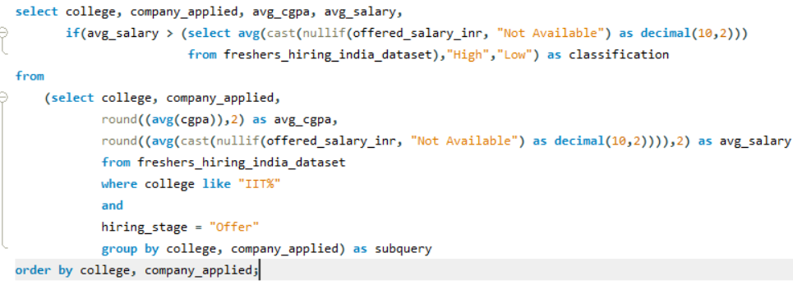
I calculated the average CGPA and average salary of candidates who studied at IIT institutes . I classified their salary as high or low by comparing the average salary with overall average salary. If their average salary is above the overall average salary, then I classified it as high else I classified it as low.
Result:
The result shows the average CGPA and average salary of candidates who studied at
IIT Institutes . The salaries are classified as high or low based on the comparison with overall average salary.
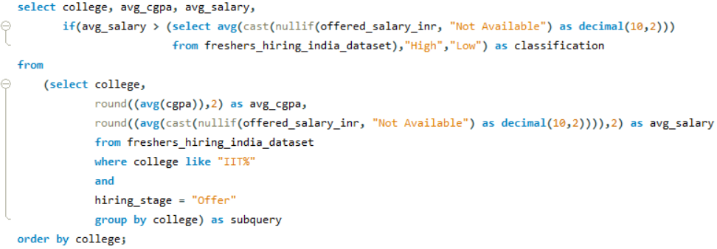
5) Platform used by companies to choose candidates
Business question:
show the top 3 job platform where companies choose most of the candidates from.
SQL approach:
I counted the number of candidates chose ( excluding the candidates who were in applied stage ie., candidates who are not chosen by the companies) from each job application platform by each company and ranked the companies from highest number of candidates to lowest and displayed only the top 3 platform where each company chose most of the candidates from.
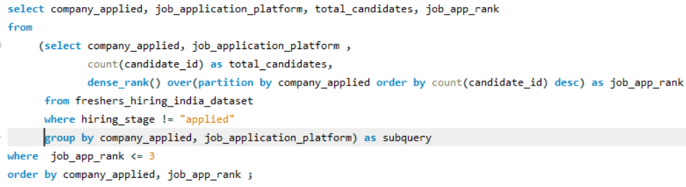
Result:
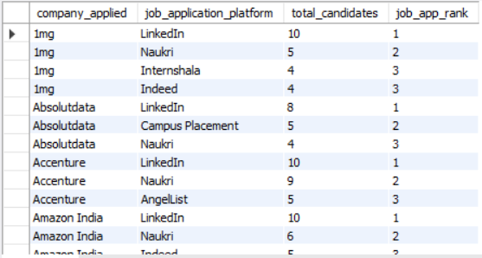
These are the top 3 platforms where each company chose most of the candidates from.
6) Candidates’ Profile Status
Business question:
show how many candidates have very strong profile and moderate profile and candidates those who have to improve.
SQL approach:
I classified the candidates’ profile into three categories as “very strong”, “moderate” and “needs improvement” based on CGPA, backlogs, internship, projects, LinkedIn connections, referral status.I classified them using CASE and WHEN and counted the number of candidates in each category.
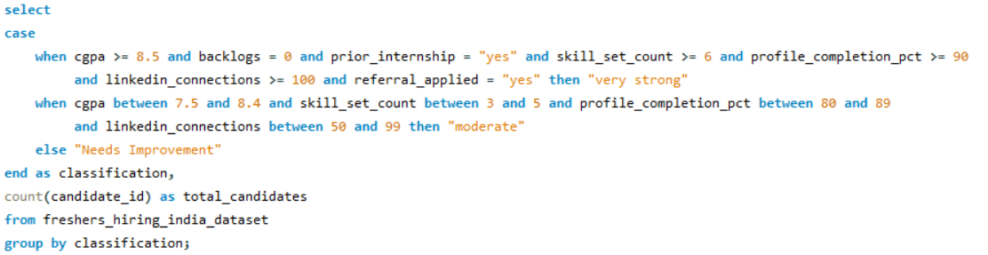
Result:
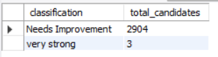
Business Insight:
There 3 candidates who have strong profile and 2904 candidates who needs to improve their profile. No candidates were classified as having moderate profile
7) Creating a User-Defined function to classify companies.
Business question:
Create a User-Defined function to classify the companies based on the salary they offer and their response time
SQL approach:
I created a user defined function to see each companies quality by the salary they offer and the time they take to respond to the candidates about the hiring process. I used CASE WHEN to classify the companies. I classified the companies as “Very good”, “good”, “moderate”, “Not good” based on their average salary and the response time. The salary column is in text format since I gave “Not available” for missing values. So I converted “Not available” into null before passing the salary to function and within the function I gave a condition that if the value in salary column is null then return “null”.
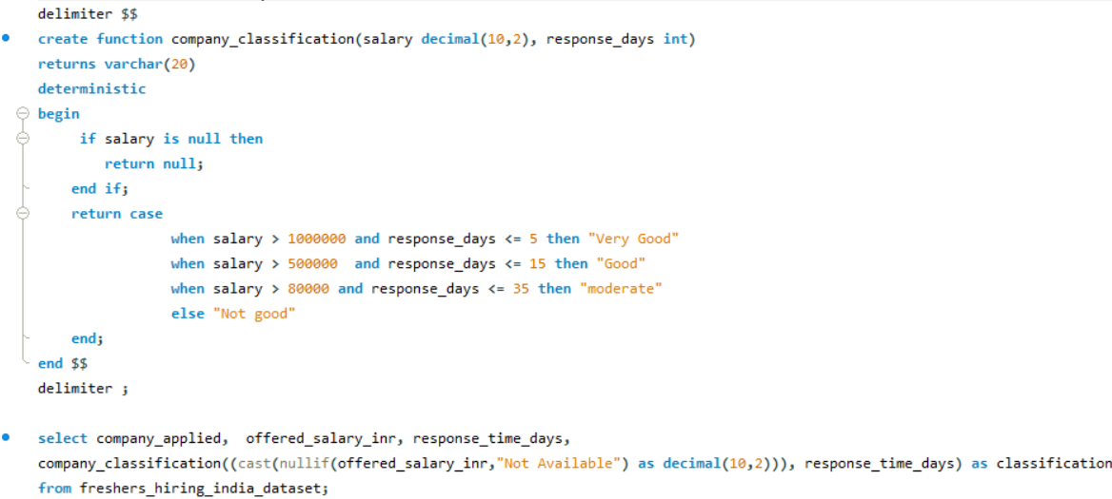
Result:
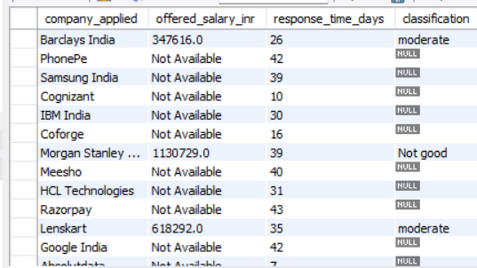
The companies are classified as “Very good”, “Good”, “Moderate” or “Not good” based on the salary they offer and the time they take to respond to the candidates during the hiring process.
8) Creating a stored procedure to filter candidates based on hiring criteria
Business question:
Create a stored procedure to retrieve candidates who meet the specified hiring criteria
SQL approach:
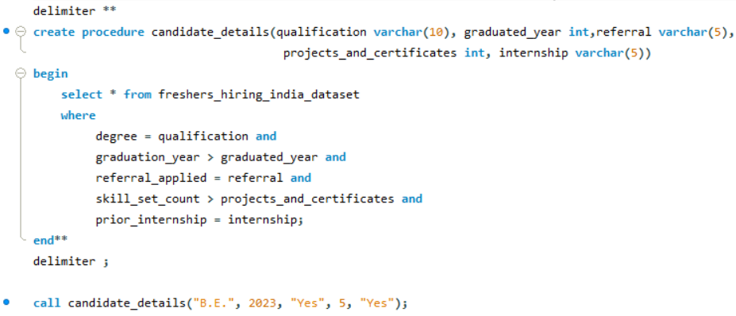
I created a stored procedure named candidate_details to retrieve candidates who meet the specified conditions. The condition is based on qualification, graduated year, referral status, number of projects and certificates, internship status of the candidates as mentioned above. I used these parameters in the where clause to filter the dataset and retrieve candidates who satisfy all the criteria. The same stored procedure can be called multiple times with different parameters to retrieve different set of candidates without rewriting the query.
Result:
Business insight:
Only one candidate satisfied the specified condition in this dataset.
9) Number of male and female candidates hired.
Business question:
How many female and male candidates were hired?
SQL approach:
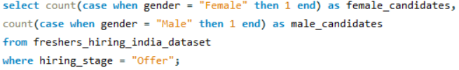
To determine the number of male and female candidates hired, I used conditional aggregation using CASE WHEN to count candidates based on their gender. I filtered the data using hiring_stage = “offer”.
Result:
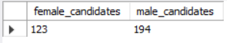
Business insight:
123 female candidates and 194 male candidates were hired during the period from 2020 to 2024 based on the data in this dataset.
10)Candidates who reached final hiring stage based on internship status
Business question:
Compare candidates with and without prior internships. For each group, calculate Total number of candidates, average CGPA, average number of projects, average number of certifications. Then determine which internship group has the higher percentage of candidates who reached the final hiring stage.
SQL approach:
I calculated the total number of candidates, average CGPA, average projects, average certificates for 2 groups, one group where candidates have done internships and the other group where candidates who haven’t done internships. I also calculated the total number of candidates who were hired in these 2 groups and calculated the percentage of candidates who were hired in these 2 groups.
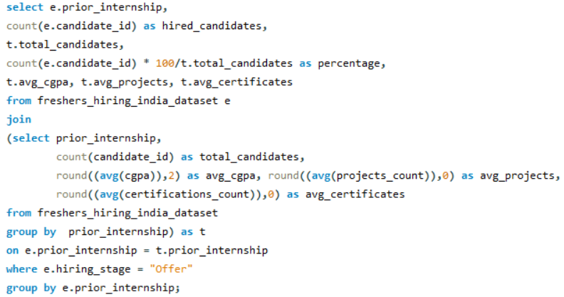
Result:
Business insight:
151 candidates were hired who have prior internship and 184 candidates were hired who have no prior internship. Candidates who have no prior internship were hired more than the candidates who have prior internship.
11) Job locations where better salary was given in each sector
Business question:
For each sector, rank the top 3 job locations by average offered salary. Exclude any location-sector combination with fewer than 5 candidates.
SQL approach:
I calculated the total number of candidates and average salary for each job location within each sector. I excluded the job locations where the total number of candidates was less than 5 and ranked the locations based on the average salary within each sector. I displayed only the top 3 locations with the highest average salary in each sector.
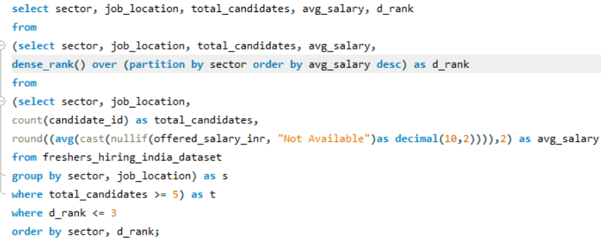
Result:
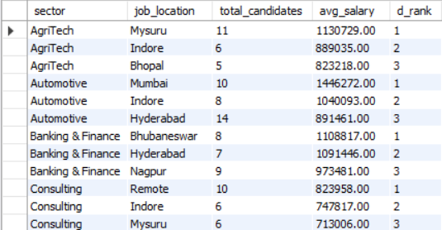
Business insight:
The output shows the top 3 cities with the highest average salary in each sector considering only the locations with more than 5 candidates
12) Were candidates with higher CGPA hired or did they reach the HR interview?
Business question:
Find all candidates who have a higher CGPA than the average CGPA of their own branch and reached at least the "HR Interview" or "Offer" stage in the hiring process. Show their candidate_id, branch, CGPA, and hiring_stage.
SQL approach:
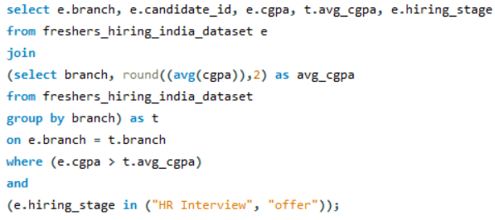
I calculated the average CGPA for each branch and displayed only the candidates who have CGPA greater than the branch-wise average CGPA in each branch. I displayed their ID number, CGPA and the stage they reached in hiring process.
Result:
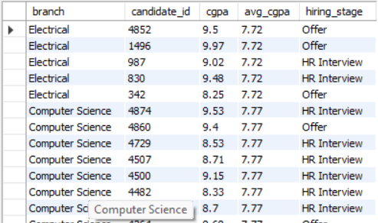
Business insight:
The candidates with CGPA greater than branch-wise average CGPA in each branch reached the HR interview level or were hired. These are such candidates.
13) Hiring success rate per job application platform
Business question:
Calculate the hiring success rate per job application platform. Show platform name, total applicants, successful offers, and success percentage. Rank them by success rate.
SQL approach:
I calculated the total number of candidates who applied in each job application platform and candidates who reached certain levels in hiring process and candidates who got hired in total. Then I calculated the total number of candidates who got hired by applying in each platform and calculated the percentage of candidates who got hired through each platform. I ranked the job application platform based on the percentage of candidates who were hired.
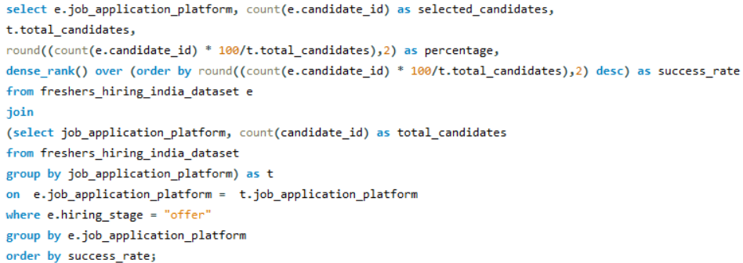
Result:
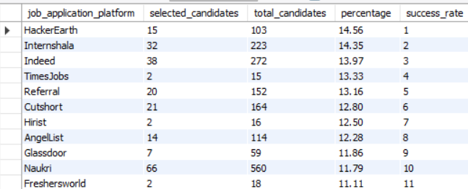
Business insight:
HackerEarth has the highest hiring success rate according to this dataset.
14) Comparing the candidates who got hired by reference with candidates who got hired without applying for reference.
Business question:
Among candidates who used referral to apply, calculate what percentage got an "Offer" in each sector. Compare this with the non-referral offer percentage in the same sector. Show both percentages and the difference.
SQL approach:
I calculated the total number of candidates who applied for referral and the number of candidates who didn’t apply for referral in each sector. Then I calculated the number of candidates hired through referral and the number of candidates hired without referral in each sector. I calculated the percentage of candidates hired through referral and the percentage of candidates hired without referral in each sector. I also calculated the difference between the total number of candidates hired through referral and candidates hired without referral.
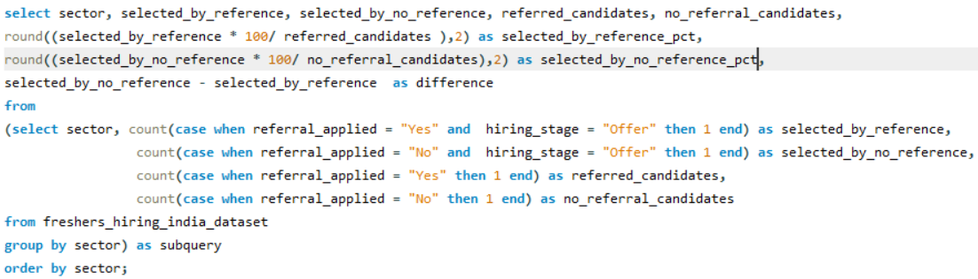

Result:
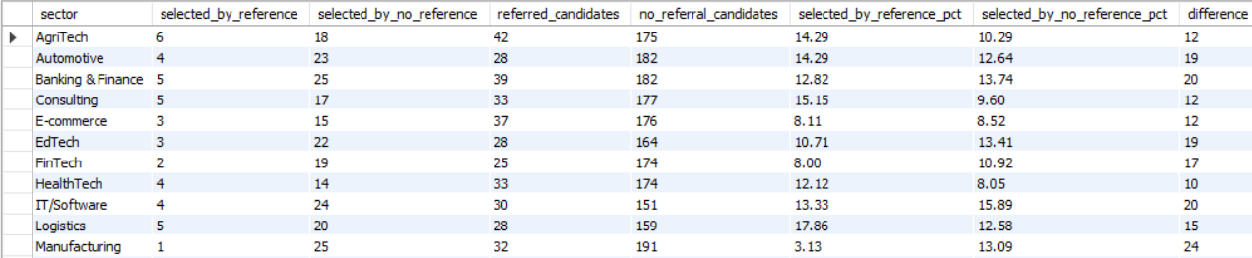
Business insight:
The output shows the percentage of candidates hired through referral and percentage of candidates hired without referral.
15) Finding potential candidates who didn’t get hired
Business question:
Identify candidates who have zero backlogs, more than 3 certifications, and no career gap but are still in "Rejected" or "Applied" hiring stage. Count them per branch and rank branches by this count.
SQL approach:
I calculated the total number of candidates who have zero backlogs, no career gap and more than 3 certifications in each branch. I filtered the candidates who were in applied or rejected stage using where clause. I ranked these potential candidates who were in applied or rejected stage in each branch based on their count.
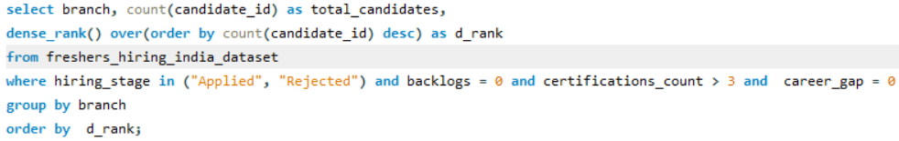
Result:
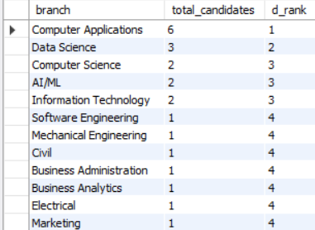
Business insight:
The output identifies potential candidates who meet the specified criteria but were in applied or rejected stage in each branch. Computer application branch has more number of such candidates.

Data Visualization
I created an interactive PowerBI Dashboard consisting of 4 pages, with a total of 17 visualizations, 6 cards and 3 slicers. I used DAX functions to create calculated measures and support analysis. The dashboard presents the analysis through different visualizations and allows users to interactively filter the data using slicers.
Data Preparation:
I cleaned the dataset in python and replaced the null values with suitable values. I replaced the null values with “Not Available” to make it logically correct. But here in PowerBI, I wanted to calculate the salary using the Offered_Salary_Inr column. Since that column is in text format because it has text value “Not available” I replaced those values with “null” and the column type to numeric values so I can perform operations in it.
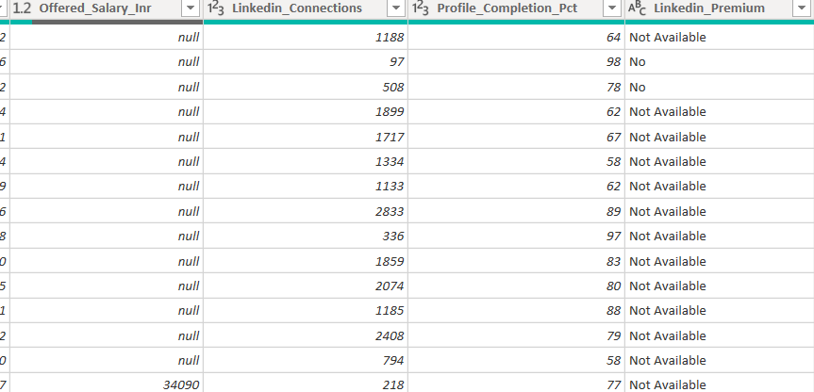

DAX Measures:
Number of candidates hired through each job application platform
I created a DAX measure called Hired candidates using CALCULATE and COUNT functions to count the total candidates chosen through each job application platform.

I create another DAX measure called Job App Platform Rank using RANKX to rank the job application platform based on the count of chosen candidates from highest to lowest.
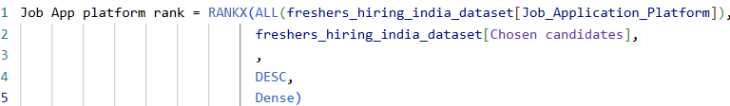
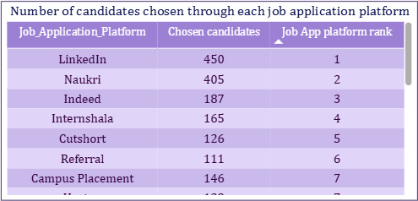
Business insight:
LinkedIn has the most number of chosen candidates with 450candidates.
Companies’ average salary and response time
I created a DAX measure called company classification using SWITCH function to classify the companies into “Very good”, “Good”, “Moderate” or “Not good” based on specified conditions for average salary and average response time.
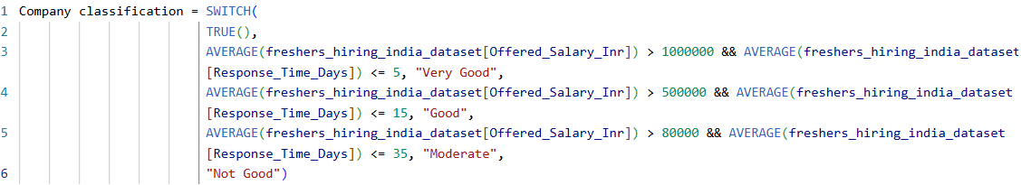
Result:
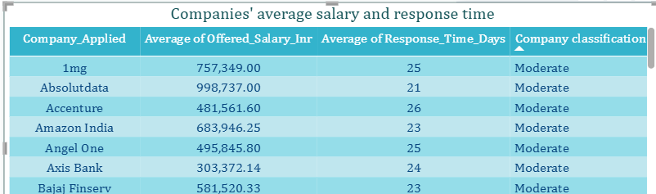
The output shows the average salary, average response time and classification of each company based on specified conditions
Business insight:
All the companies fall under the “Moderate” category based on the specified conditions for average salary and average response time.
IIT students salary classification
I created a DAX measure called salary average using CALCULATE and ALL which gives the overall average salary as output. The ALL function removes the filter context for each IIT institutes and shows the overall average salary for all the IIT institutes.
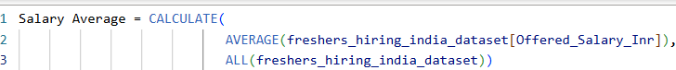
I created another DAX measure called IIT students salary classification using IF condition to classify the average salary of students of each IIT institutes into “High” or “Low”. If the average salary of students of each IIT institutes is above the overall average salary it is classified as “High” if not, it is classified as “Low”.
Result:
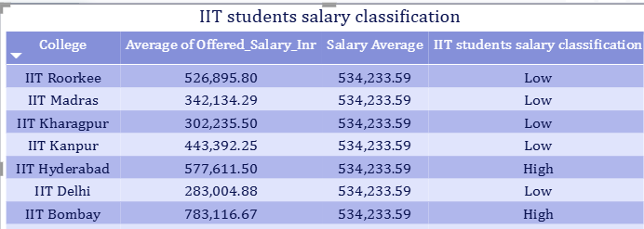
Business insight:
The output classifies the average salary of IIT students as “High” or “Low” by comparing it with the overall average salary. For example, candidates who studied at IIT Hyderabad and IIT Bombay were getting salary higher than the overall average salary.
Candidates’ Profile Status:
I created a DAX column called Profile status using SWITCH function to classify the candidates profile into “Very strong”, “Moderate”, “Needs improvement” based on specified conditions. I did this to show the number of candidates who have strong, Moderate profile and the candidates who have to improve their profile. I also showed the candidates who were hired in each category.
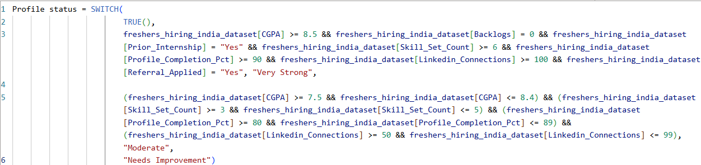
Result:
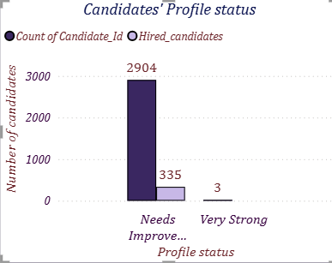
The analysis shows most of the candidates (2904) fall under “Needs improvement” category, very few candidates (3) have very strong profile, no candidates fall under the “Moderate” category. All the 335 candidates who were hired fall under “Needs Improvement” category.
Most recruited degrees:
I created a DAX measure called Chosen candidates using CALCULATE and COUNT functions to count the candidates who progressed beyond “Applied” stage of hiring process. This measure was used to identify the candidates chosen by the companies for each degree.
I created another DAX measure called Degree rank using RANKX function to rank the degrees based on the number of chosen candidates from highest to lowest.
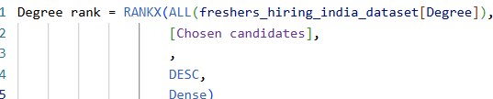
Result:
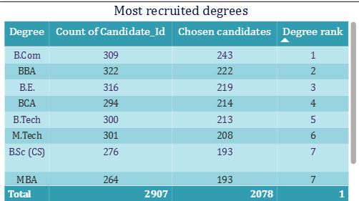
I showed the total number of candidates in each degree and the candidates who were chosen by the companies for hiring. I ranked the degrees based on the count of chosen candidates from highest to lowest.
Business insight:
Candidates with B.Com degree were chosen the most based on this dataset.
Classification of colleges by average CGPA and average backlogs
I created a DAX measure called classification using IF and AND functions to classify the colleges based on average CGPA and average backlogs.
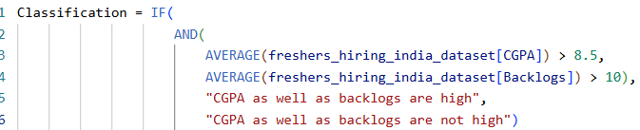
Result:
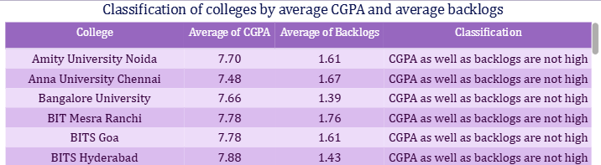
Business insight:
There are no colleges where both average CGPA and average backlogs are not high.
Number of candidates hired in each company
I created a DAX measure called company rank using RANKX function to rank the companies based on the number of candidates hired from highest to lowest. I have already created a DAX measure called hired candidates which shows the count of hired candidates.
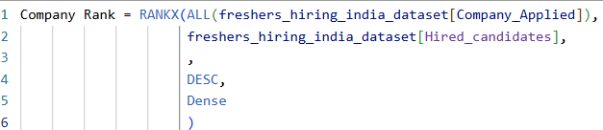
Result:
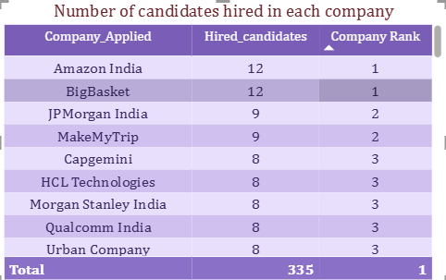
Business insight:
Amazon India and BigBasket hired the most number of candidates with 12 candidates.
Average Response Time
To check the average response time is above the accepting limit that is 15 days. I found the minimum number of days to respond and set it as minimum value and I found the maximum number of days to respond and set it as maximum value. I set the target value as
15 days which is the accepting limit. I found the average response time and I checked if the average response time is above the target value.
Result:
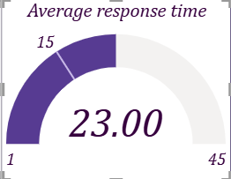
Business insight:
The average response time is 23 days which is above the target value 15 days. That implies the companies take a lot of time to respond to the candidates during hiring process.
Dashboards
Page 1
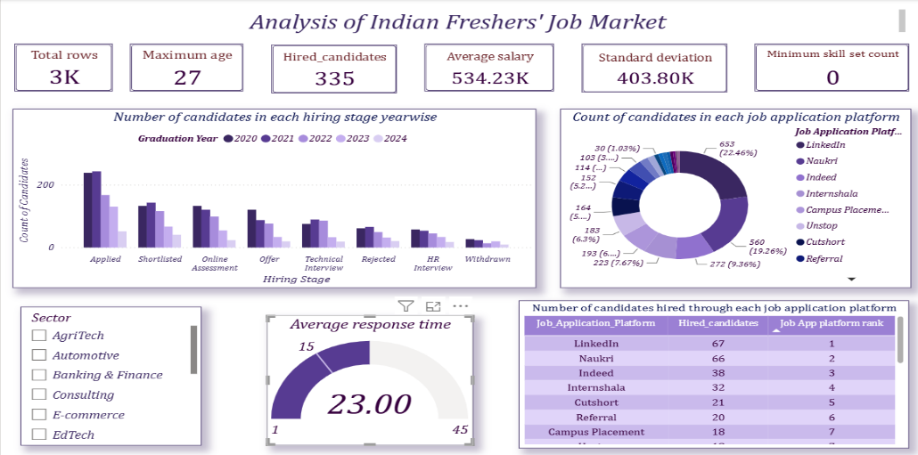
Page 2
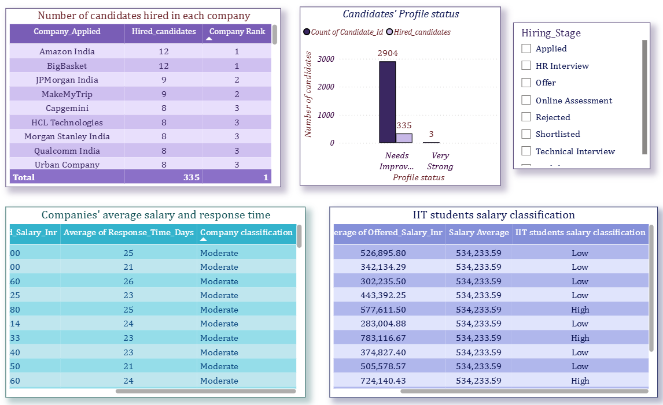
Page 3
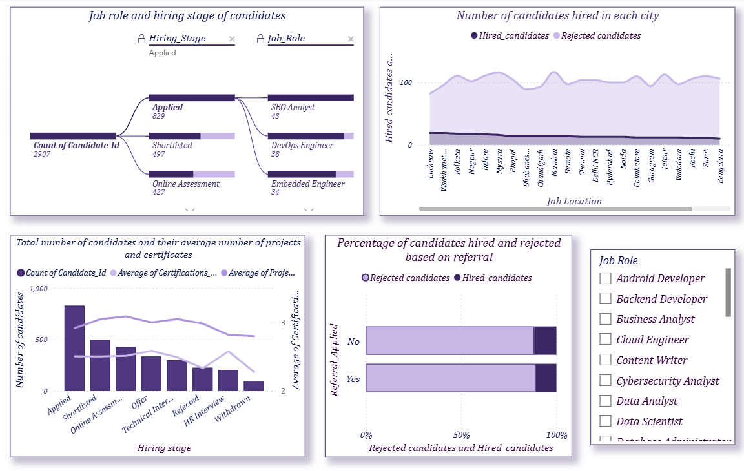
Page 4
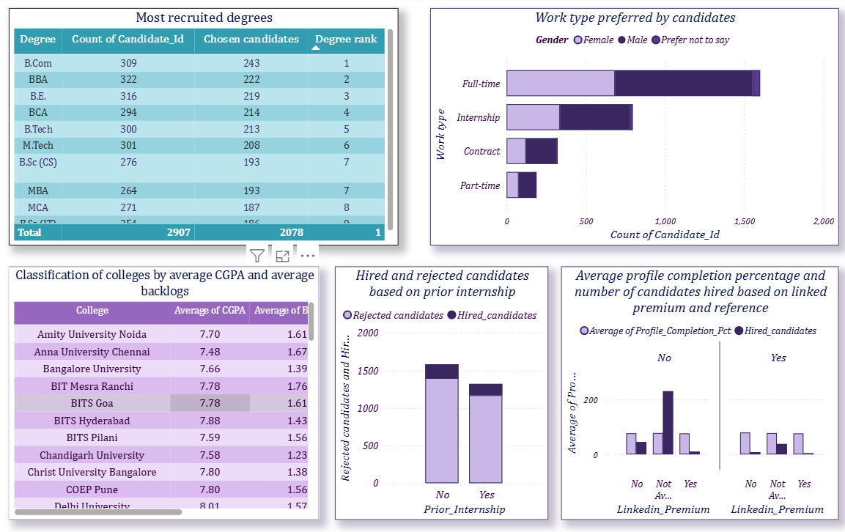
These are the dashboards pages I created to visualize the business insights I derived from the freshers hiring dataset.

Key Insights
This dataset contains data about freshers job market during the period from 2021-2024
- Gender-wise hiring
Male candidates were hired more than female candidates during the period
2021 – 2024. 194 males candidates and 123 female candidates were hired.
- Hiring process based on Candidates’ graduation year
Candidates who graduated in 2020 and 2021 applied the most and also
progressed beyond the “Applied” stage. These graduation years also have the
highest number of hired candidates.
    - Candidates’ degree and colleges
- Candidates with B.Com degree were chosen the most by the companies.
- There were some candidates who studied at IIT institutes and still get low salary compared to other IIT candidates.
- There were some candidates with zero backlogs, zero career gap and more than three certifications but still didn’t get hired. Most of candidates are from computer application branch compared with the other branches.
- Some companies hired more candidates with backlogs than candidates with no backlogs.
- Internship affecting hiring
Candidates with no prior internship experience were hired more than the
candidates with prior internship experience.
- Job application platform
LinkedIn and Naukri had the highest number of chosen candidates among
the job application platforms.
- Companies
- Fractal Analytics, Cognizant, Tata Steel, Absolutdata are the companies which provides better salary and respond quickly during hiring process and this finding is based on the specified conditions.
- Amazon India and BigBasket had the highest number of hired candidates during the period 2021-2024.
- The analysis suggests that the number of projects alone is not sufficient to explain hiring outcomes. Other factors may also influence the hiring outcomes
- Job role
More candidates were hired for roles such as Backend developer, Cloud
Engineer, Digital marketing executive compared with other roles during
the period 2021-2024.
- Work type
Full-time job was the most preferred work type. Out of 2907
candidates, 1600 candidates preferred full-time job.
- Job location
Lucknow and Visakhapatnam had the highest number of hired
candidates among the job locations.
- Time taken to respond by companies
Average time taken by each companies to respond to candidates during
hiring process is more than 20 days, indicating that the hiring process
generally involved a considerable waiting time for candidates.
- Salary provided by companies
- Cognizant offered the highest salary among the companies in the dataset.
- The correlation analysis shows that, candidates with high CGPA tended to receive low salary while candidates with low CGPA tended to receive high salary. However, CGPA alone may not determine salary, there might be other factors associated with salary.
- Hiring stage distribution
The dataset contains eight hiring stages with the highest number of
candidates in “Applied” stage.
- Profile status of candidates
Most of the candidates need to improve their profile . Only 3 candidates
have very strong profile. But all the candidates who were hired fall under
“Needs improvement” category.
- Hiring based on referral
Candidates without referral were hired more than the candidates who
applied with referral.

Conclusion
This project analyzed the hiring patterns of freshers based on their educational qualifications, skills, sectors, job locations, job application platforms, hiring stages, companies and other factors. The analysis identified patterns in candidate selection, salaries and hiring outcomes. The PowerBI dashboard presented these findings interactively to provide an overall view of the freshers hiring process.

